# Introuction

The heavy metal app is a simple application that guides a user to do a measurement with a PalmSens device to measure if a liquid sample contains a concentration of heavy metal.

The application is made so the user can have a simple flow to go through and do the measurement with just a few clicks.

In the next chapter an overview will be given of the functionality of the application. It will describe the flow that the user goes through to do a measurement. The succeeding chapters will go more in depth. First it will describe how to configure the app by using the admin options and the last chapter serves as a technical guideline for customizing and developing the application from code.

# Application Flow

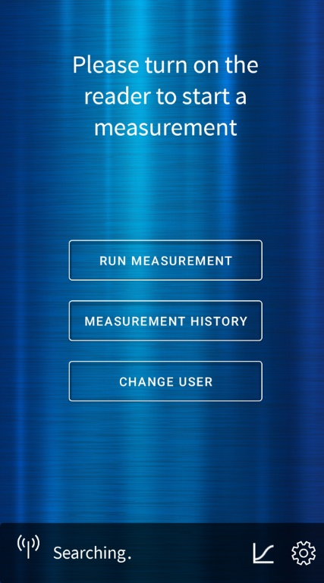When a user starts the application, a screen will be shown where a user can log in. The application has a simple user management functionality where a user can be created by creating one with providing a name. The user functionality mainly exists to couple a measurement to a user. This way multiple users can use the app on the same device without seeing each other’s measurements. A user is also used for personal settings like language.

In the future different user roles can be added. This way you can have an admin user that has access to more advanced options.

After the user logs in it the home screen. From this home screen the user can start a measurement. Meanwhile in the background the Bluetooth scanner starts scanning for devices. When user decides to run a measurement, he will be presented with a list of devices that are found. A user can select a device from the list to connect.

After the application has successfully connected to a device a user has to select an analyte to continue. The application comes with a few default analytes. However, a user can upload a custom analyte with its custom configuration. This process is described in chapter 3.2

After selecting an analyte and setting a measurement name the measurement will start. After it’s completed the user can continue to the measurement finished screen. In this screen a user can take a maximum amount of three pictures that will be attached to the measurement. A user can also share a report. This will generate a pdf report with the measurement result and the pictures attached. This report can be shared through e-mail, google drive etc.

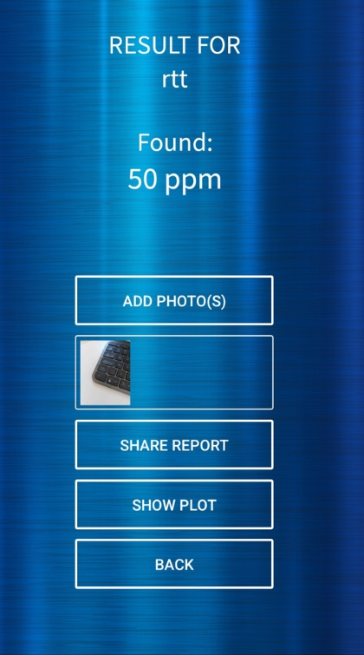From the measurement finished screen the user can also get a display of the plot with the measurement data. Aside from this a user can start a new measurement or go to the home screen.

A user can open a list of previous measurements from the status bar. If a measurement is selected from this list, then the user will be presented with a view that is similar to the measurement finished view with the same functionality.

# App Configuration

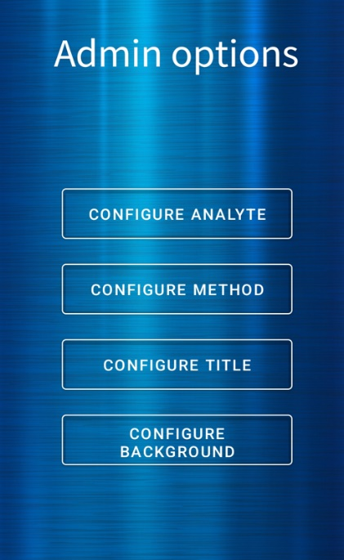The application can be configured to fit the styling of the user.

To access the app configuration menu, you have to put a user in admin mode. This can be done from the user settings. When the admin mode is toggled on then from the home screen you can configure the application with the following options:

## Custom style

You can change the following styling of the application:

* Title that is shown in the top screen
* The background image of the application

Both options can be changed from the admin options. These changes will only take effect after the application has been restarted. When changing the background consider that the styling of the application is based on a dark background (for example white buttons with white frames). Changing it to a light background will make it confusing for the user.

## Custom analyte

The heavy metal application comes with its own default analytes that a user can use. This analyte calculates the concentration from the measurement data.

A user can add their own analyte configuration from the Configure Analyte menu. In this menu you can import an analyte by selecting a file from either the device itself or from another source like e-mail or google drive.

The file that is selected must be a json file with the following properties:

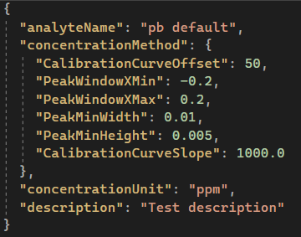

In the example above you see the properties with its values. If you make a custom analyte, then you have to use the same properties, but you can change the values.

## Custom method

The heavy metal application uses a PalmSens method (psmethod) to execute the measurement that is used to detect heavy metals. The result of this measurement is used by the analyte to calculate the concentration.

The heavy metal application comes with a default psmethod which is a Differential Pulse Voltammetry. However, an admin user can change this method by selecting the configure method option in the app configuration menu. Currently the analysis is set up for Differential Pulse Voltammetry and Square-Wave Voltammetry, the analysis will need to be modified when using a different technique.

When a user selects this option, they can select a file from the device or other sources like e-mail or google drive. The file has to be of type .psmethod. When a psmethod file is selected the current psmethod file is overwritten. This means only 1 psmethod file can be used at a time.

# Application structure

The application is set up with Xamarin. Xamarin is a cross platform framework that makes it possible to create applications that is compatible with Android and IOS.

The language that Xamarin uses for the front-end is XAML. The backend is written in C#.

This chapter will describe the application structure from a developer point of view.

## MVVM

The application uses MVVM to structure the flow of control. MVVM has 3 kind of components:

* View: This is the part that the user sees. With the application this means the part that is written in XAML.
* ViewModel: The part that is connected to the view which sends updates of the user interaction to the model
* Model: The part that contains the business logic and responsible for the data

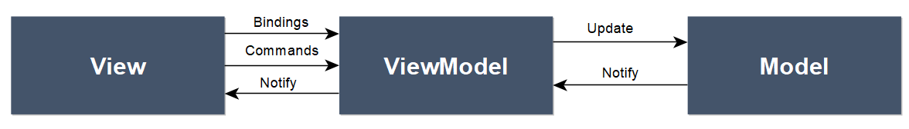

With the MVVM structure the front-end part written in XAML connects with the viewmodel through Bindings and commands. The commands register user interaction and sends it to the viewmodel. The bindings make sure that the data on the view gets updated when that data is changed in the view model.

By using bindings and commands the view doesn’t have to contain any code-behind which means this doesn’t have to be unit tested. Also, the view model doesn’t have any connection with the view. This means that it’s loosely coupled. The view model just updates its properties and through bindings on the view side the view will be updated.

The model receives updates from the view model and process these updates through the business logic. The result will be sent as notifications to the view model mainly through events. This will have the same effect as the relation between views and viewmodels the model doesn’t know anything about the view model. This decreases the coupling and makes the application more modular.

For more information about MVVM please visit the following link: <https://docs.microsoft.com/en-us/xamarin/xamarin-forms/enterprise-application-patterns/mvvm>

## Services, DTO’s and repositories

Even though in the last chapter the model is represented as a single component. This component consists of several types of classes:

* Services: These contain the business logic and can be called from the view model
* Repositories: Repositories are connected to the services. Repositories have method which are responsible for manipulating or retrieving data
* DataOperations: The class that has the database configuration
* DTO’s: Data transfer objects (DTO) are classes responsible for carrying data between processes. These classes are shared by the viewmodel and model.
* 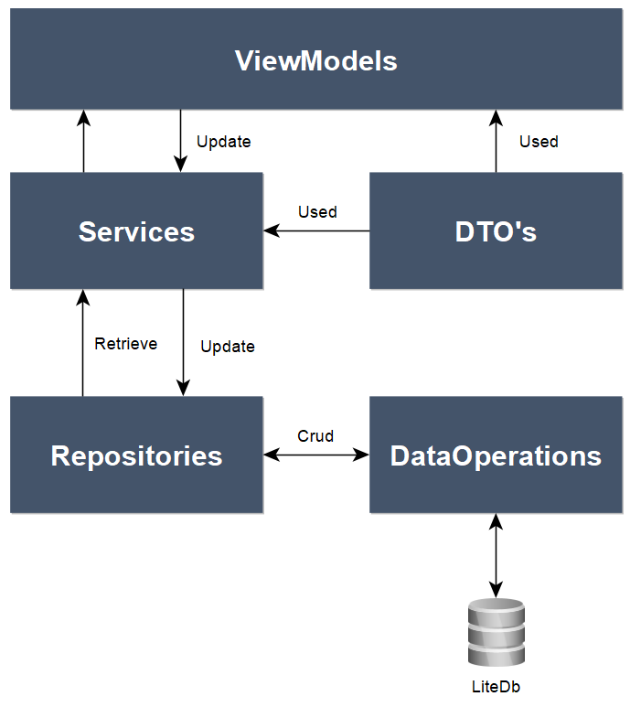

The view models are connected to services. However, services are not aware of the view models classes. They only send requested data back or send notifications through events. Services can connect to other services to handle business logic or connect to one or more repositories to handle data related requests (saving, retrieving etc.).

Repositories have CRUD (create, read, update, and delete) methods for data handling. Repositories don’t have any connection to services or other repositories. They do have a connection to the DataOperation class which has database operations

For now, repositories handle only database related actions. In the future this can also be data related calls to export data (for example HTTP calls).

The services, repositories and data operations classes have a one-on-one interface. The communication between the model classes and viewmodel goes through interfaces. This serves as an extra layer of abstraction. For example, if we switch to a different kind of database then we only have to change the concrete data operations class.

## Project’s structure

The heavy metal application is a Visual Studio solution which consist of the following projects:

**PSHeavyMetal.Forms**

This project has the view, viewmodels and front-end related helper classes like converters.

**PSHeavyMetal.Core**

This project has the services, repositories and data operations classes and their respective interfaces. It also has helper classes only used by the model classes. The services in this project are all cross platform.

**PSHeavyMetal.Common**

This project contains classes that are used by both the Core and Forms projects. For now, it’s only the DTO classes and some helper classes that are used by both projects.

**PSHeavyMetal.Android**

The Android solution that is created based on the Xamarin projects. It has some specific android configuration in the main activity class. And implementations of platform specific services.

**PSHeavyMetal.IOS**

The IOS solution that is created based on the Xamarin projects. Like the Android project it has IOS specific configuration and services.

**PalmSens.Core.Simplified.XF.Application & Infrastructure**

These two projects contain interfaces for platform specific services that must be implemented in the platform specific projects. It also contains classes that are used by those services.

## Dependency injection

The application makes use of dependency injection containers. This mean that all services, repositories and view models are configured in the startup class of the .Forms project. To use a service or repository you can simply add it to the constructor:

The advantages of using dependency injection with IOC containers is that first, you have to declare outside dependencies in the constructor of the class. Which makes it less error prone. Also, it’s easier for unit testing by using mocks for the outside dependencies. Another pro is this way makes sure you only use 1 instance of a class is used.

If you create a viewmodel, repository or service that needs to be registered then you can add it to the *DIContainers* class in the .Forms project. You can add the class to 1 of the existing methods:

You can add the class with its representing interface to the list. After that you can use the class from constructors.

For more information about dependency injection please visit the following link: <https://docs.microsoft.com/en-us/dotnet/core/extensions/dependency-injection>

## Navigation

The navigation of the application app is done with a NavigationPage. This page has a navigation stack that keeps track of which page to display. This means that you have a home view which is the main page. If a user navigates to other pages, then that page is being pushed on the stack. If the user is using the back button or any other button that goes back a page, then that page is being popped of the stack.

For the heavy metal app there is a custom navigation dispatcher to support pushing and popping of pages asynchronously in view models instead of using code behind or view code in the view model.

To use this, you can call the static NavigationDispatcher class in the app and call the push or pop method:



You can use the NavigationViewType to select the view where you want to navigate to. If you use the Pop method, then you don’t have to specify a page.

## Connection

The heavy metal app can connect to a PalmSens device either through Bluetooth or usb. For Bluetooth the reader should be on. When it’s on it will detect PalmSens devices nearby. This detection will run in the background and will reset after every 5 seconds. When a device is selected then it will connect and disable the device detection.

The device service in the heavy metal app handles all device related functionality for the application and serves as a mediator between the heavy metal application and the PalmSense simple wrapper.

## PS simple wrapper

For connecting to devices, the heavy metal app uses the PalmSens simple wrapper. This is a wrapper class around the PalmSensPalmSens core library. The simple wrapper is also used for SDK users to make applications for PalmSens devices.

## Adding views and view models

In case of adding your own custom views and view models you have to follow the following steps:

1. Add a view by creating a xaml ContentPage.
2. Add a corresponding view model by creating a C# class
3. Set the viewmodel as binding context in the code behind of the contentpage  
   
4. Add the view to the NavigationDispatcher by adding the view to the NavigationViewType enum and add the translation from enum to the actual page in the PageSelector method within the NavigationDispatcher. This way a view model can use the NavigationDispatcher to navigate to the view



1. Last step is to add the view model to the InitializeViewModels method in the DIContainers class. This makes sure the App.GetViewModel method in step 3 can find the viewmodel. The viewmodel is added with a transient lifecycle this means it only exists when the corresponding view exists.

1. If you want to use services within a view model you can just add them to the constructor

## Database

The heavy metal application uses LiteDb to store objects and data. LiteDb is a no-sql database that is embedded. This means that the database is installed on the device that uses the application.

The way LiteDb works is that it has collections of C# classes that are saved. This means if you want to save data to the database you have to structure this data in a C# class. With this class you can call the IDataOperations interface. This interface has all the methods to save, load and delete data from the database.

The following example is a save method from the user repository

The user information structured in the User class is saved to the database. If you want to load the data, you can use the load methods of the IDataOperations interface. You must put the class you want to load between the <T> brackets

